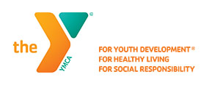
2020 Baseball Registration Now Open
Pittsburg Area YMCA
Dates Subject To Change According To Covid -19 Updates
Register on-line or pick up forms from 9-1 at the YMCA
Kinder – T-Ball Ages 3-5 years old
Boys T-Ball Grades K-1 --- Girls T-Ball Grades K-1

Boys and Girls Pitching Machine Grades 2-3
Important Dates
Cost – Members $30.00 May 1st Sign Ups Begin
Non-Members $45.00 June 7th Deadline
June 11th Coaches Meeting

Season Starts June 17th Games will be played on Wednesday and Friday nights
Contact: Chris Bearden (cbearden73@gmail.com) or 417-844-9266
Sports Director

